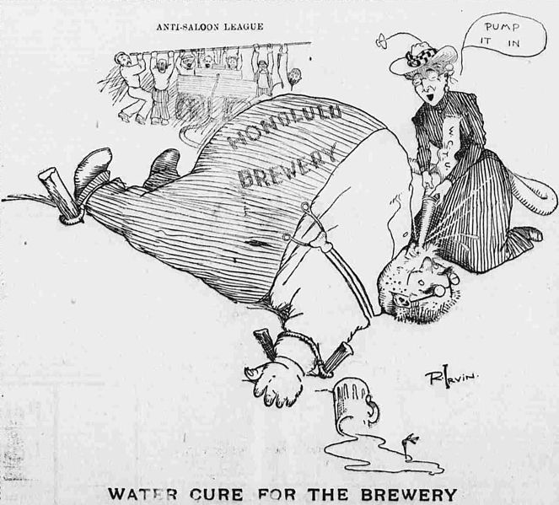

This political cartoon about the temperance movement shows the anti-saloon league and the Women’s Christian Temperance Union working together to get rid of all sales and drinking of any alcoholic beverages. In this cartoon, posted by the Hawaiian Gazette on May 23, 1902, a man is passed out as a result of drinking beer. It does a good job showing the effects of alcohol on one’s body and how the WCTU is for the prohibition of alcohol in the America. The man represents the Honolulu Brewery and the lady pumping water into the man’s mouth is wearing a WCTU sash and strapped the man down to get him to drink water. The WCTU in particular thought that the consumption and sale of alcohol caused other social problems such as crime and increased poverty. Even though the WCTU protested other topics (suffrage, sanitation, economy), temperance was their main focus and is what pushed them to start their organization. They wanted to get Americans to become successful and they wanted to better society all together.

. “The Hawaiian Gazette, May 23, 1902,” Library of Congress, LOC, last modified May 23, 1902, http://chroniclingamerica.loc.gov/lccn/sn83025121/1902-05-23/ed-1/seq-1/

