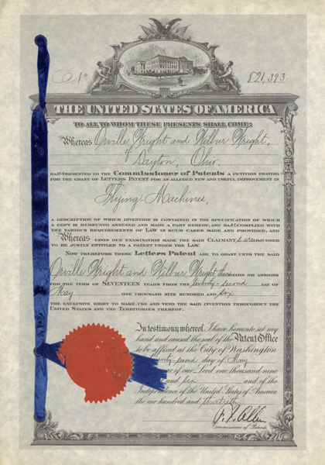

The Wright Brothers were two Americans who were recognized with inventing the world’s first successful airplane. In order to protect the invention, they worked hard to receive a patent and after several attempts they were finally given one by the United States in 1906. However, even with this patent, it did not stop others from trying to steal their ideas. For example, another United States aviation pioneer, Glenn Curtiss, flew the White Wing airplane that appeared to be just like the Wright Brother’s designs. Eventually, the brothers sued Curtiss because him and his company, the Herring-Curtis Company, stole their original and successful design. As a result, both sides spent a lot of money on court fees but their still wasn’t any success on bringing both parties to an agreement. In 1913, Orville Wright won the court case, but was now without his brother Wilbur because he died of typhoid fever in 1912. Because Orville won, Curtiss was now unable to design planes that copied the brothers. Therefore, since the famous brothers did not give up on receiving the patent for their legendary design, creation and invention, they were able have a victory in this case. During this case, because the patent wasn’t issued in other countries, the Europeans ignored the entitlements of the Wright Brothers. Mainly the French and German have freely produced their design without restrictions. All in all, even with the patent that the Wright Brother’s received, it did not stop others from stealing their long and hard work. Basically, during this time, patents were not of full effect and others could easily sneak around and take their idea.

University Libraries, Wright State University, last modified June 18th, 2012, http://www.libraries.wright.edu/special/wright_brothers/info_packet/wright_patents.php

