The National Women’s Trade Union League of America
The National Women’s Trade Union League of America (also known as WTUL) has influenced the work place in many ways, though it focuses on women in the workplace, their jobs and rights that come along with said jobs. This union brought together many sets of women from the working-class to the wealthy upper-class.
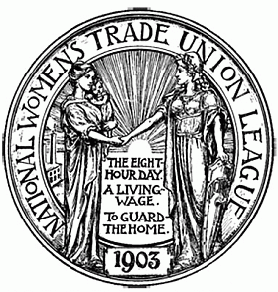
In 1903 in Boston Massachusetts, the National Women’s Trade Union League of America was founded. It’s first president was Boston’s own Mary Mortan Kehew (Wolfskill 2010) . That same year The National Women’s Trade Union League of America held its first meeting in Boston Massachusetts. The National Women’s Trade Union League of America “Viewed women’s workers primarily in their capacity as oppressed workers, but also recognized that all women, regardless of class were united by the “Bonds of womanhood”.” ("National Women's Trade Union League of America" 2012). In other words the upper-class wealthy women joined up with the common working-class. Together forming The National Women’s Trade Union League of America. They worked together on a picket line and getting everyone’s hands dirty to prove a point, and attempting to make the life of working women better. All of the while they knew there was a chance of getting arrested, and some did. They did not let that stop them from working for their cause.
This union offered support to those fighting for women’s rights when other unions held back their support. One of the most vocal champion for working women, It was a strong group of women. It focused on forging a bond between the working-class women and the upper-class women. Together they would make a difference. Following the deadly Triangle Fire, The National Women’s Trade Union League of America pushed hard on forming a “Bureau of ire Prevention” ("1911 Triangle Factory Fire: Legislative Reform at State and Local Level" 2011) to prevent another travesty from happing again. In October of that same year New York “passed an act creating the Bureau of Fire Prevention, aimed at ending confusion over the responsibilities of various city departments and agencies for inspections, codes creation, and enforcement” ("1911 Triangle Factory Fire: Legislative Reform at State and Local Level" 2011). This would never happen if The National Women’s Trade Union League of America and other women’s union groups had not pushed for it. Other cities followed the example of New York. Due to the Working Union from 1911, women have a have a better work quality now.

Work Cited
Wolfskill, . "National Women's Trade Union League of America Records." Last modified 2010. Accessed September 22, 2012. http://hdl.gov/loc.mss/eadmss.mss.ms010120.
Harvard College, "National Women's Trade Union League of America." Last modified 2012. Accessed September 25, 2012. http://ocp.hul.harvard.edu/ww/nwtul.html.
"The 1911 Triangle Factory Fire: Legislative Reform at State and Local Level." Last modified 2011. Accessed October 1, 2012.

