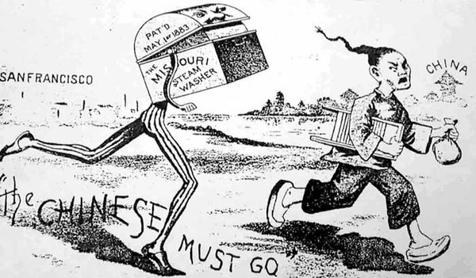
http://www.theatlantic.com/politics/archive/2012/06/apologizing-for-america-finally-the-parties-can-agree/258761/

This political cartoon from the late 19th century depicts what life was like for the Chinese living in America during the time period of the Chinese Exclusion Act. In this cartoon, an American is running the Chinese man out of American soil to go back to his homeland. Many Americans did not like the Chinese in the United States because they seemed to take away jobs and lower wages. This specifically happened in California, which is why San Francisco is located on this picture. They easily immigrated there because they came across the Pacific Ocean by boat and California was the first State on the West coast of the United States. There is a steam washer with legs because some Chinese performed predictable labor such as steam washing, instead of mining for gold. This is classic for Chinese immigrants to do and it is still likely to see Chinese people working in dry cleaners or tailor shops. This is specific to the Chinese Exclusion Act because it was invented in 1883, a few years prior to when the act was passed. Gold mining was the cause of the large number of Chinese immigrating into the United States to begin with. Therefore, technology and innovation could have also been the cause of the Chinese being driven into the United States. Even though many Americans wanted the Chinese gone, all immigration restrictions were put to an end in 1943.

James Follows, “Apologizing for America: Finally the Parties can Agree!” The Atlantic, June 20, 2012, http://www.theatlantic.com/politics/archive/2012/06/apologizing-for-america-finally-the-parties-can-agree/258761/

