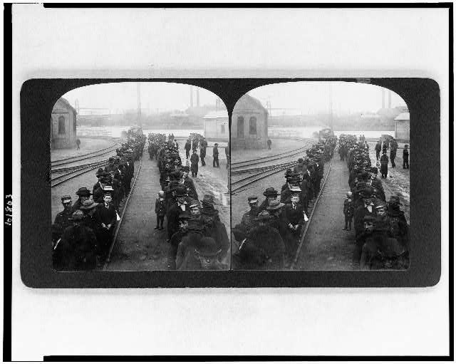

This image is of the employees working for the US Steel Corporation in the early 1900s waiting for their pay. This picture shows that there was a long line; therefore, many employees having jobs by this one big business. Not only that, the employees worked even with the long hours and short wages. For example, in 1907, the average daily pay was $2.70. Skilled workers might average $5 a day, and only one in one hundred workers earned more than $6 a day. With few exceptions, a twelve hour work day was the rule until the mid 1930s. One could also tell they waited on these gruesome days regardless of the cold weather.

. Library of Congress, “Pay line,” Library of Congress, accessed September 25, 2012, http://www.loc.gov/pictures/item/90713695/

