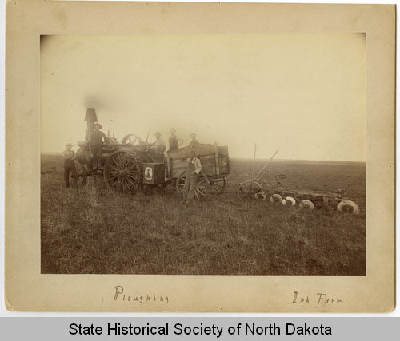

State Historical Society of North Dakota. “Plowing with Steam-Powered Tractor at the Ink Farm Wahpeton, North Dakota.” Accessed September 24, 2012. http://www.digitalhorizonsonline.org/cdm4/item_viewer.php?CISOROOT=/uw-ndshs&CISOPTR=3220

Plowing with Steam-Powered Tractor at the Ink Farm Wahpeton, North Dakota
This picture was taken between 1900-1910, by an unknown photographer at an Ink Farm in Wahpeton, N.D. The picture is significant because it shows many factors pertaining to the golden age of agriculture. Six unknown men are shown operating a steam-powered tractor pulling a plow through a field. The steam-powered engine is powered by the burning of twigs, sticks and wood. Looking at the land surrounding the men, the ground is very dry and lacking trees, as was the land given to citizens in the Enlarged Homestead Act. Excessive plowing on dry land with no natural ground cover like trees, was one reason for the Dust Bowl of the 1930s. Also, we see it takes six men to operate the tractor, where new advances would require only one man and therefore lead to higher unemployment, contributing to the Great Depression. The picture shows typical rural farm life of the time and is an example of the golden age’s success.

