Primary Source: Hassmann, Carl. "The Meat Market." Library of Congress. Accessed September 7, 2012. http://www.loc.gov/pictures/resource/ppmsca.26067/
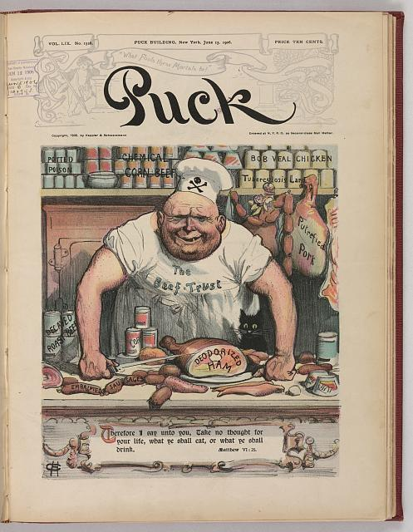.
This is an illustration that depicts the unsanitary meat and how the corrupt trusts were harming the public with unsanitary handling and processing methods. In the picture, the meat in the background is labeled “potted poison, chemical corn beef, [and] embalmed sausages.” The butcher has “The Beef Trust” written across the front of this apron. This print was published in a popular magazine to make citizens aware of the unsanitary meat processes. This picture was published in 1906 as a part of Puck Magazine, which addressed political, economic, business, and social events through satirical cartoons. It was drawn by Carl Hassmann, who worked and drew for the publication for many years. There magazine included caricatures of political figures and poked fun at many of the happenings going on in the United States and throughout the world during the time period. The magazine was published from 1871 to 1918, so it humorously illustrated many of the events that took place during the American Progressive period.

