Laura West
HIS 949
Dr. Varley
November 26, 2012
Gender Event Annotation: Meredith College
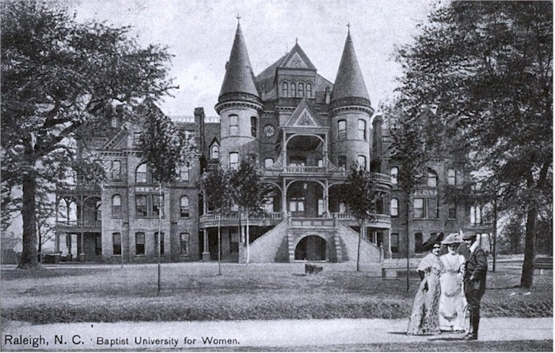
Although Meredith College was not established until the year 1899 and at this time it was known as Baptist Female University, the idea for a woman’s college dates back to the year 1835. In 1835 the North Carolina Baptist State Convention appointed a committee “to consider the establishment of a female seminary of high order,” (Meredith Archives). Although they began to consider this idea it wasn’t until three years later when Thomas Meredith saw the need for a “first rate course of female education,” (Meredith Archives). However due to the civil war as well as the general lack of interest for female education it took fifty years for Thomas Meredith’s idea to be put into action. This idea was put into action by Leonidas Polk, when he introduced a resolution to the Convention for a Baptist female college, at the convention his resolution is adopted unanimously, (Meredith Archives). By September 1899 a school was built at the corner of Edenton and Blount in Raleigh, North Carolina. The school was formally named Baptist Female University. It was staffed with nineteen faculty/staff members and had enrolled more than 200 students. The school named James C. Blasingame as its president. At this time room and board cost a mere $36 with tuition being $17.50 a small price compared to what students pay today.
In 1902 Baptist Female University had its first graduating class. The graduating class consisted of ten women who would become known as the “Immortal Ten”. “At Commencement in 1902 nine B.A. degrees and one M.A. degree were awarded by what was then called The Baptist Female University. In addition, that day one diploma in music, two diplomas in art, one certificate in music and two certificates in art were given,” (Meredith Archives).By the year 1909 Baptist Female University had officially changed its name to Meredith College in order to honor Thomas Meredith. Thomas Meredith was one of the first men to see the need for an institution for women’s education. After seventy-six years the board of trustees believed he deserved the honor of having the women’s college bear his name. Since 1909 Meredith College has continued to grow and break ground as women’s college, and now in 2012 is the only women’s college in Raleigh, North Carolina and one of the many few in the state entirely.
Meredith College Archives, “Meredith Timeline”.
http://www.meredith.edu/library/archives/meredith_timeline.html

