Brittany Coley
HIS 949
Culture Primary Source Annotation

WTTW. “McKinley Park – Biking the Boulevard – Geoffrey Baer Tours – WTTW.” Accessed November 20, 2012. http://www.wttw.com/main.taf?p=74,4,3,1,6.

“History of Illinois Park Districts: Decade by Decade.” Accessed November 20, 2012. http://www.lib.niu.edu/1997/ip970923.html

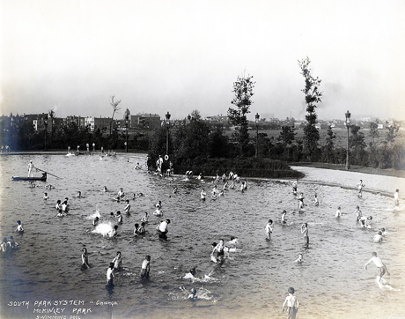

This is an image of the wading pool at McKinley Park, a park in the South Park System of Chicago, Illinois. This was the first wading pool to be built in the South Park System. McKinley Park was built after it was found that the existing parks were not enough to support the rapidly growing Chicago population. The superintendent of the South Park Commission, J. Frank Foster, who was influenced by social reforms like Jacob Riis and others from the time, wanted to create an escape from the mundane life of the working class and immigrants. To do this, they acquired land near the Union Stockyards and began building McKinley Park. The park was named after President William McKinley and a statue was placed at the entrance in his honor.

From this image, you are able to see how popular the park became after its opening. It was so successful in fact, that the following year, plans were drawn up to create a new system of parks in Chicago and it became a model for the rest of the nation as well. From these plans, 14 neighborhood parks were established in the congested neighborhoods of Chicago to provide “breathing spaces” for families. The South Park Commsion’s small parks were an immediate success and influenced the Playground and Recreation Association of America to hod its first annual convention in Chicago in 1907.

Since its creation, McKinley Park continues to serve the communities surrounding it in Chicago, Illinois by providing children and families with a safe place to play. All of Chicago’s parks were combined during the Great Depression, creating the Chicago Park District that exists today.

